**Task 1:**

create database assignement1

create table shopping_history (

product varchar(100) not null,

quantity integer not null,

unit_price integer not null)

insert into shopping_history (product, quantity, unit_price) values ('milk', 5, 37);

insert into shopping_history (product, quantity, unit_price) values ('bread', 2, 50);

insert into shopping_history (product, quantity, unit_price) values ('cheese', 2, 200);

insert into shopping_history (product, quantity, unit_price) values ('jaggery', 3, 100);

insert into shopping_history (product, quantity, unit_price) values ('sugar', 50, 9);

insert into shopping_history (product, quantity, unit_price) values ('curd', 2, 44);

insert into shopping_history (product, quantity, unit_price) values ('phenyl', 3, 120);

insert into shopping_history (product, quantity, unit_price) values ('dettol', 1, 300);

insert into shopping_history (product, quantity, unit_price) values ('apple', 3, 210);

insert into shopping_history (product, quantity, unit_price) values ('sattu',1, 180);

select * from shopping_history

select product, quantity*unit_price as total_price from shopping_history;

|  |  |
| --- | --- |
| PRODUCT | TOTAL_PRICE |
| milk | 185 |
| bread | 100 |
| cheese | 400 |
| jaggery | 300 |
| sugar | 450 |
| curd | 88 |
| phenyl | 360 |
| dettol | 300 |
| apple | 630 |
| sattu | 180 |

**Task 2:**

**use database "ASSIGNEMENT1"**

create table phones(

name varchar(50) not null,

phone_number integer not null

)

select * from phones

insert into phones values

('jack', 1234),

('Lena', 3333),

('Mark', 9999),

('Anna', 7582),

('Tipu', 3313),

('Maria', 3323),

('Keemo', 3363),

('Santyo', 3393),

('teena', 3353),

('meena', 3359);

create table calls (

id integer not null,

caller integer not null,

callee integer not null,

duration integer )

select * from calls

insert into calls values

('01', 1234,9999,7),

('02', 3333,9998,6),

('03', 9999,9997,2),

('04', 7582,9996,1),

('05', 3313,9995,2),

('06', 3323,9994,4),

('07', 3363,9993,3),

('08', 3393,9992,2),

('09', 3353,9991,1),

('10', 3359,9990,1),

('11', 1234,8999,4),

('12', 3333,8998,5),

('13', 9999,8997,1),

('14', 7582,8996,1),

('15', 3313,8995,3),

('16', 3323,8994,1),

('17', 3363,8993,3),

('18', 3393,8992,2),

('19', 3353,8991,1),

('20', 3359,8990,1);

select sum( c.duration) , p.name

from phones p left join calls c on p.phone_number = c.caller group by p.name

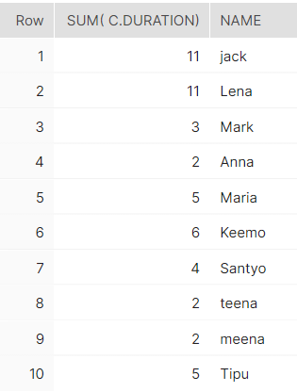

As per the query result, Jack and Leena total call duration is more than 10 minutes.

Also,

select name from phones where phone_number in

(select caller from (select caller,count(*), sum(duration)> 10 as sumdur from calls group by caller)where sumdur = true) order by name asc

RESULT:

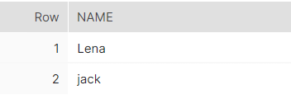

**Task 3:**

**Output display is just one column balance**

You can add the following data in the table

USE DATABASE "EXPERRIMENT"

---tranaction table--

CREATE TABLE TRANSACTIONS (

AMOUNT INTEGER NOT NULL,

DATE date not null );

--table data feeding---

insert into TRANSACTIONS values ( 2000, '2000-01-01');

insert into TRANSACTIONS values ( -20, '2000-01-05');

insert into TRANSACTIONS values ( -500, '2000-01-10');

insert into TRANSACTIONS values ( -900, '2000-01-20');

insert into TRANSACTIONS values ( -35, '2000-01-01');

insert into TRANSACTIONS values ( -800, '2000-02-01');

insert into TRANSACTIONS values ( 3000, '2000-02-05');

insert into TRANSACTIONS values ( -900, '2000-02-10');

insert into TRANSACTIONS values ( -30, '2000-03-11');

insert into TRANSACTIONS values ( -90, '2000-03-11');

insert into TRANSACTIONS values ( -30, '2000-03-21');

insert into TRANSACTIONS values ( 900, '2000-04-11');

insert into TRANSACTIONS values ( -100, '2000-04-21');

insert into TRANSACTIONS values ( -200, '2000-05-01');

insert into TRANSACTIONS values ( -9, '2000-05-03');

insert into TRANSACTIONS values ( -3, '2000-05-03');

insert into TRANSACTIONS values ( -100, '2000-05-03');

insert into TRANSACTIONS values ( -1, '2000-05-29');

insert into TRANSACTIONS values ( 2000, '2000-06-01');

insert into TRANSACTIONS values ( -20, '2000-06-05');

insert into TRANSACTIONS values ( -500, '2000-06-10');

insert into TRANSACTIONS values ( -900, '2000-06-20');

insert into TRANSACTIONS values ( -35, '2000-06-01');

insert into TRANSACTIONS values ( -800, '2000-07-01');

insert into TRANSACTIONS values ( 3000, '2000-07-05');

insert into TRANSACTIONS values ( -900, '2000-07-10');

insert into TRANSACTIONS values ( -30, '2000-08-11');

insert into TRANSACTIONS values ( -90, '2000-08-11');

insert into TRANSACTIONS values ( -30, '2000-08-21');

insert into TRANSACTIONS values ( 900, '2000-09-11');

insert into TRANSACTIONS values ( -100, '2000-09-21');

insert into TRANSACTIONS values ( -200, '2000-09-01');

insert into TRANSACTIONS values ( -9, '2000-09-03');

insert into TRANSACTIONS values ( -3, '2000-09-03');

insert into TRANSACTIONS values ( -11,'2000-10-03');

insert into TRANSACTIONS values ( -1, '2000-10-29');

insert into TRANSACTIONS values ( 900, '2000-11-11');

insert into TRANSACTIONS values ( -100, '2000-11-21');

insert into TRANSACTIONS values ( -200, '2000-11-01');

insert into TRANSACTIONS values ( -9, '2000-11-03');

insert into TRANSACTIONS values ( -3, '2000-11-03');

insert into TRANSACTIONS values ( -100, '2000-12-03');

insert into TRANSACTIONS values ( -1, '2000-12-29');

delete from transactions where date = '2000-04-21'

delete from transactions where date = '2000-12-03'

delete from transactions where date = '2000-04-21'

delete from transactions where date = '2000-10-03'

-- end of table creation--

--update table to add column month and transaction type--

alter table transactions

add column month varchar(20);

update transactions set month = month(date)

alter table transactions

add column transaction_type varchar(20);

update transactions SET transaction_type = CASE

WHEN amount>0 THEN 'credit'

ELSE 'Debit'

end;

--end table update---

--------total transaction excluding monthly charges---------------

select sum(amount) as total_transac from transactions

------------------end of query------------------------------------

----charge per month caluclaton if applicable and totoal debit ----

with new_transaction (count1, sum1, month1) as

(

select count(*), sum (amount) , month from (select * from transactions where transaction_type = 'Debit') group by month

)

select sum(sum1) as total_debit , ( count(*)* 5) as card_charges from new_transaction where count1>3 and sum1<-100;

---------------------end of query--------------

--total transaction--

select sum(amount) as total_transac from transactions

balance = total_transact-card_charges

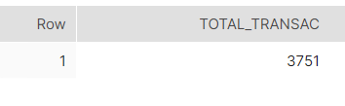

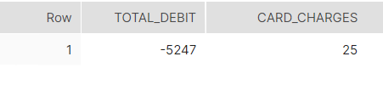

Balance= Total_transac-Card_charges =3751-25 = 3726